**DayOut App**

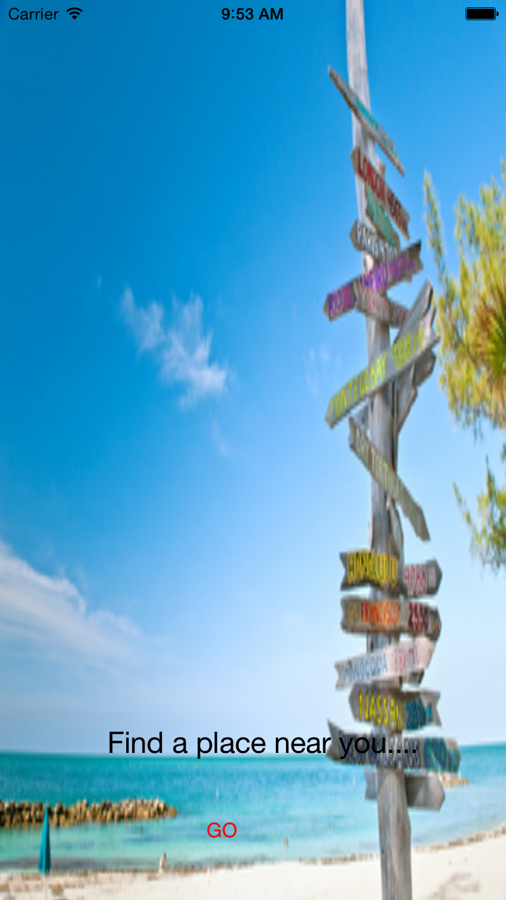**Screenshots**:

